Steven Reveles

Braulio Duran

Isabella Linarez

Alex Bernatowicz

## **Campus Connect Low-Fidelity Prototype**

Revised Requirements, Personas, Scenarios:

**Requirements:**

1. As a student, I want to be able to see my friends’ availability in real-time so that I can coordinate meetups more easily and avoid long text conversations.
2. As a commuter, I want to be able to view my friends’ and classmates’ schedules so that I can find mutually convenient times to meet before needing to leave campus early.
3. As a student involved in multiple activities, I want the app to suggest meeting times based on my friends’ schedules and my own so that I can schedule meetups without manually comparing availability.
4. As a student, I want to input my class schedule and availability so that my friends can best know when I am available.
5. As a student, I want to see a visual representation of my own schedule and my friends schedules to quickly see any available times for group study.

**Personas:**

Persona 1: Wendy - The Commuter Student

* **Senior** studying **Computer Science** that has a **60+ minute commute.** She is **not involved in extracurricular activities** but has a **part-time job.** Her schedule is very tight and needs to **leave campus early** to avoid traffic.

Goals:

* To meet friends on campus without staying too late and to have quick meetups between classes.
* To reduce the back-and-forth of scheduling meetups via texting on social platforms

Frustrations:

* Long commutes make it difficult to stay on campus after classes, limiting opportunities for socializing.
* Texting back and forth to coordinate meetups is inefficient, especially when friends don’t respond quickly.
* She doesn't always know when her friends are free, making it hard to schedule meetups spontaneously.

How can we help?

* Show her friends’ availability in real time, allowing her to plan social interactions quickly.
* Help her stay connected with friends despite her busy schedule.

Persona 2: Marty - The Super Involved Student

* **Junior** studying **Mechanical Engineering** and **lives on campus.** **On the board of two clubs**, attends weekly meetings, and participates in study groups.

Goals:

* To quickly schedule meetups with friends without conflicts between his classes, club meetings, and study sessions.
* To better manage his time so he can balance social activities with academic commitments.

Frustrations:

* It’s difficult to find time to hang out with friends due to conflicting club and class schedules.
* He often gets too occupied with too many commitments, and his friends leave campus early, so coordinating meetups is challenging.

How can we help?

* Provide him a comprehensive view of his friends’ availability and his own commitments, so he can see where free time overlaps.
* Can help him use his time efficiently, so he can focus on both academics/social life without stress

**Scenarios:**

Scenario 1:

It’s the middle of the week, and Marty has a group project due soon. His study group is trying to find a time to meet but are struggling to find a time that works for everyone; it feels hard to find any time between class and his club meetings. Before, he would text the group chat multiple messages and had to wait a long time for everyone to respond—a process that takes an indefinite amount of time.

Marty opens Campus Connect and quickly inputs the names of his group members that he has already connected with on the app. The app scans everyone’s schedules and suggests a time slot when they are all free, right before Marty’s evening club meeting.

A meetup suggestion is sent out by Marty with just a few taps. The members of the group receive notifications and confirm their availability in no time. Because of Campus Connect, Marty was able to schedule his study session without the usual back-and-forth messaging, saving him time and energy to focus on his club meeting for later.

Scenario 2:

Christina is sitting alone in the campus library at 3:00PM after her classes. She has an exam coming up in 2 days and is studying for it but is worries that she might not understand certain concepts and wants to get a study group going with some of her friends. She knows that their schedules usually conflict but opens the app to find a suitable time for everyone.

Christina opens the *Campus Connect* app and is greeted by her calendar view showing her upcoming classes and commitments for the week. She selects “Friend View” where she is able to see the calendars of her friends, Mark and Lilly. On the top of the screen an alert is displayed saying “All Available: Today 4:00PM - 5:30PM”, Christina selects the option to schedule study group for that selected time slot labeling it “Study Group for CS 211 exam” also entering the location to meet and selects “Create”. The app sends a notification to her friends, Mark and Lily, who will be notified of the study group that Christina had created. Chrsitina receives a notification right away displaying that both Mark and Lily confirmed her study group invitation.

Since both Mark and Lily won’t be available until 4:00PM, Christina decides to begin reviewing her lectures in preparation for exam while she waits. An hour later both Mark and Lily show up at the library where Christina was sitting and they all being to study for the exam together helping each other explain different concepts and questions that they had.

Experience Design Model:

The MVP will focus on core features that have been derived from the revised requirements, personas, and scenarios, which address key user needs:

1. **Real-time availability viewing (Requirement 1):** This feature will show the availability of friends in real-time, eliminating the hassle of texting friends to find out when they are available.
2. **Personal schedule input (Requirement 4):** Users will be able to add their own schedules, such as classes and other commitments throughout the day, making it easier to manage their availability.
3. **Visual representation of schedules (Requirement 5):** This feature will allow users to view overlapping free times with their friends, which will help them coordinate their meetups and study groups faster.

These three main features address the key frustrations of our personas. Wendy, who has a long commute needs to see when her friends are available during her time on campus. Also, Marty who has multiple commitments and is very busy, needed a tool to help him visualize his availability with his friends’ to be able to identify times in which they are all available.

Our data collected also motivated our decisions to focus on these features, when asked what is a challenge you face when trying to coordinate meetups with friends, we received many responses such as, “Finding a time to meet up that works with everyone’s schedule” and “Not everyone is available and its hard to know everyone's schedule” which help us narrow down on these key features.

Some of the features that we are choosing not to address in this semester’s scope of work are the feature to schedule time for study groups within the application and also the suggestion of meeting times.

Our design model will include an interactive tab to switch between a “Personal” and “Friend” view, which will include a viewable calendar. The calendar itself will also be able to display the “Daily”, “Weekly”, or “Monthly” view which can be chosen by the user. Each button will provide feedback through a change in color or slight expansion when selected.

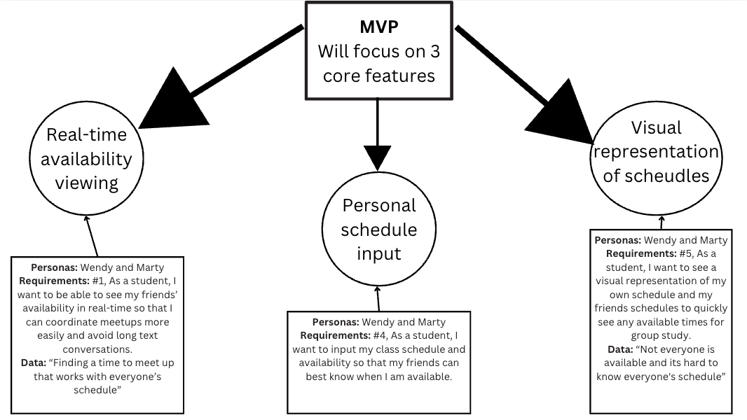

Visual Program

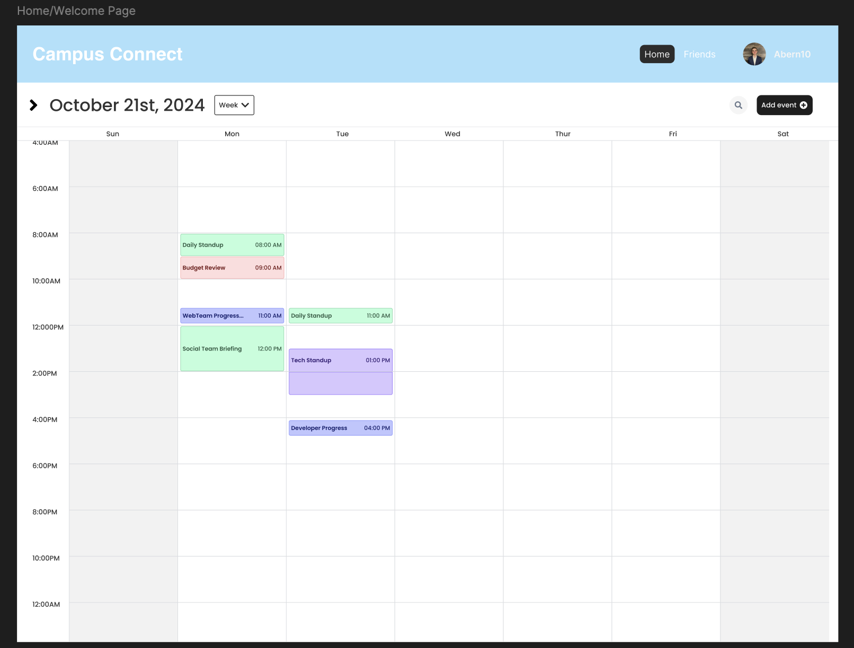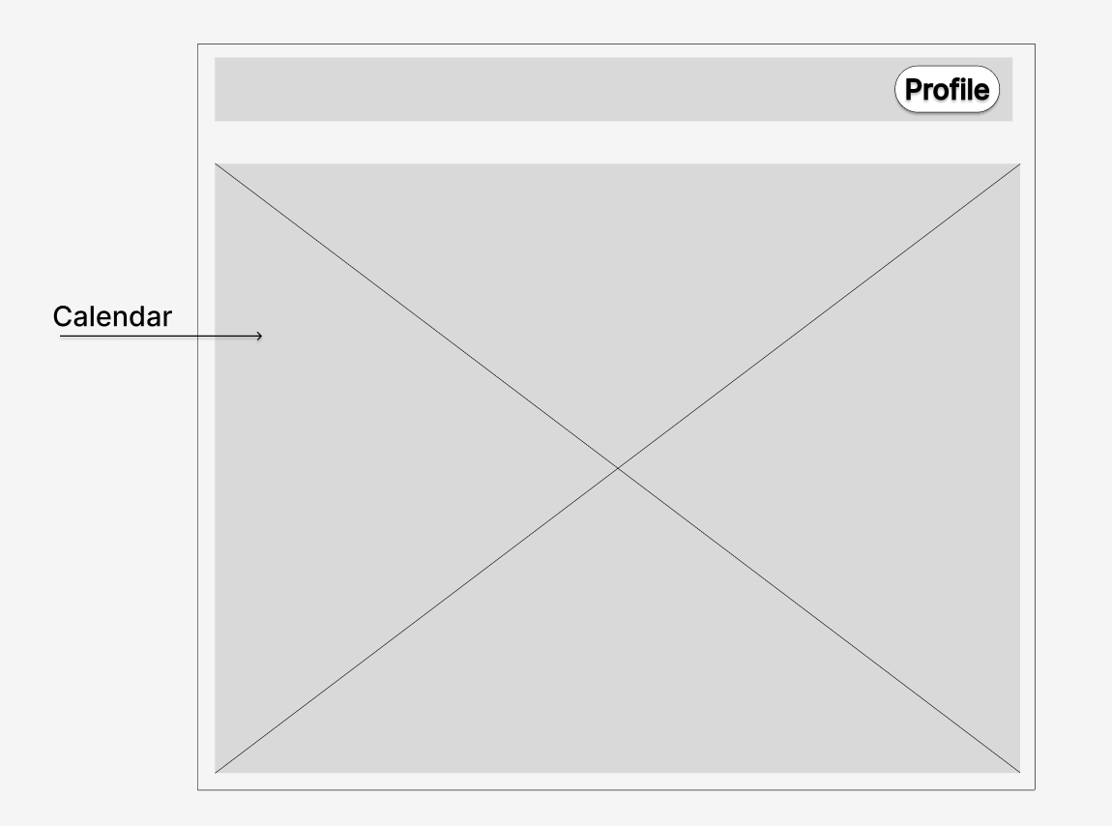

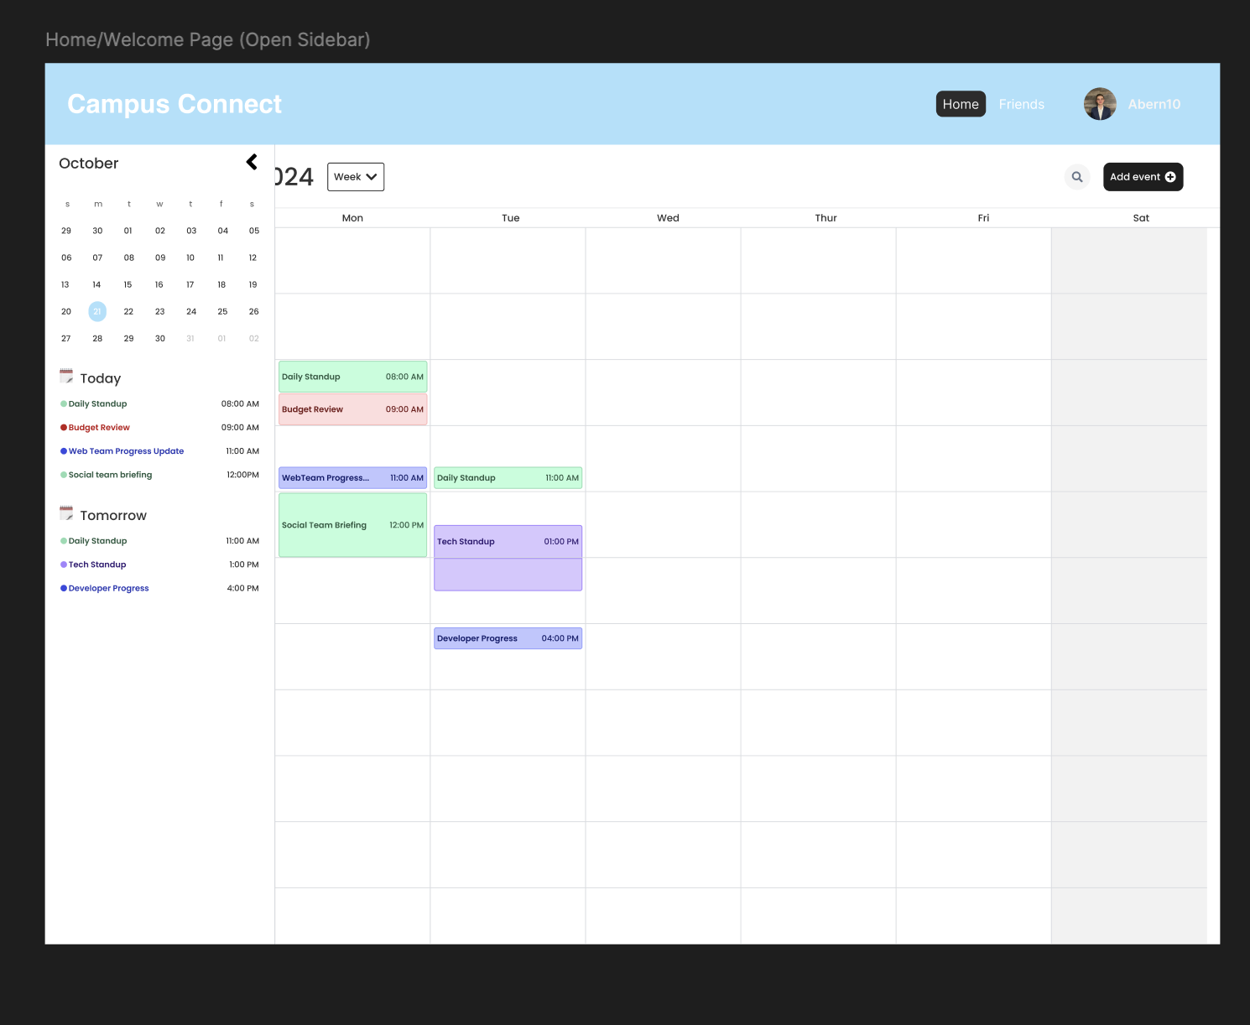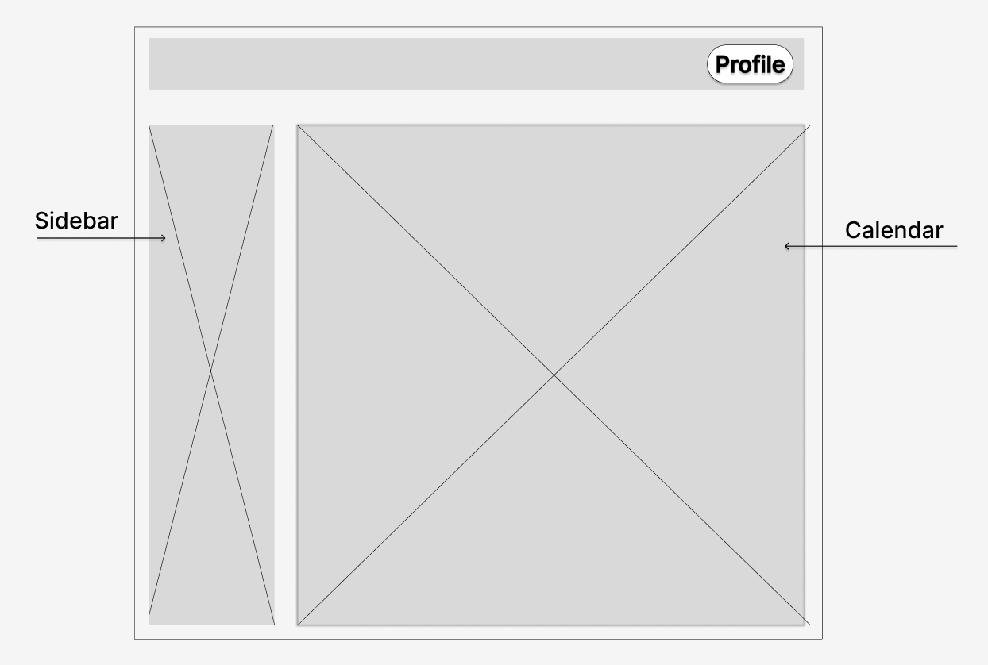

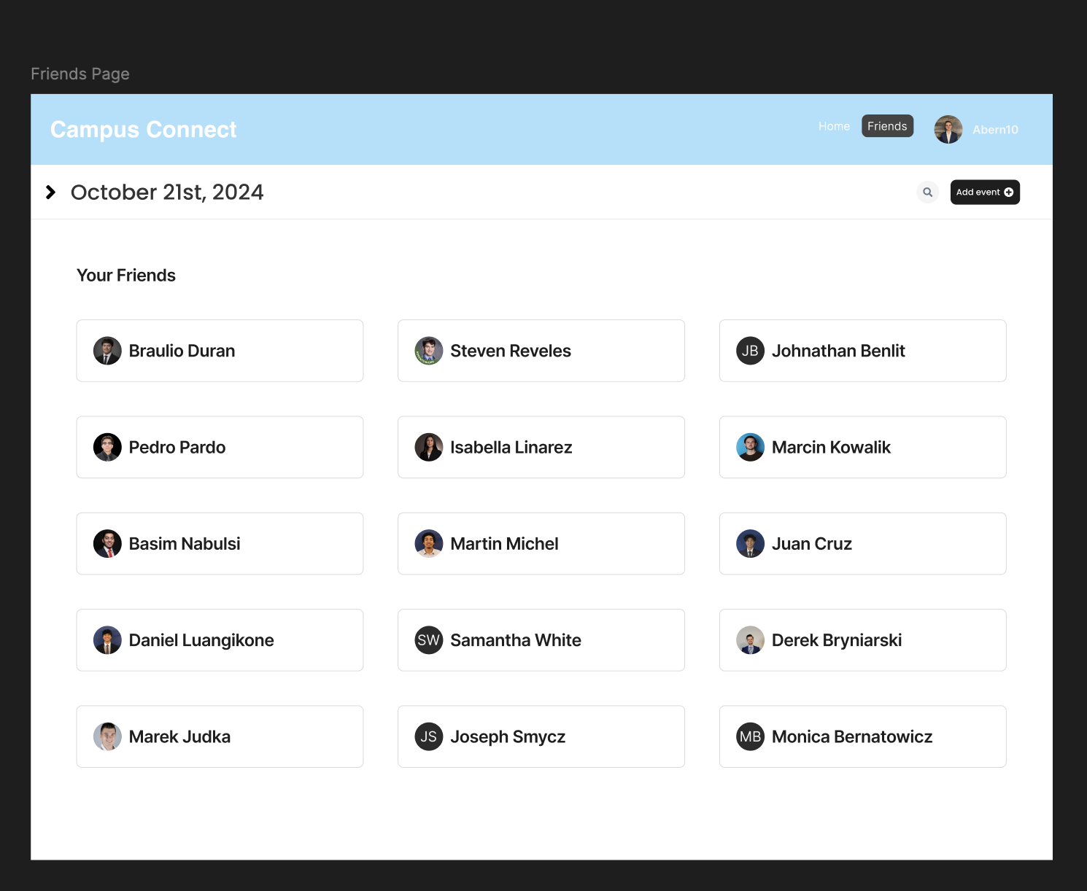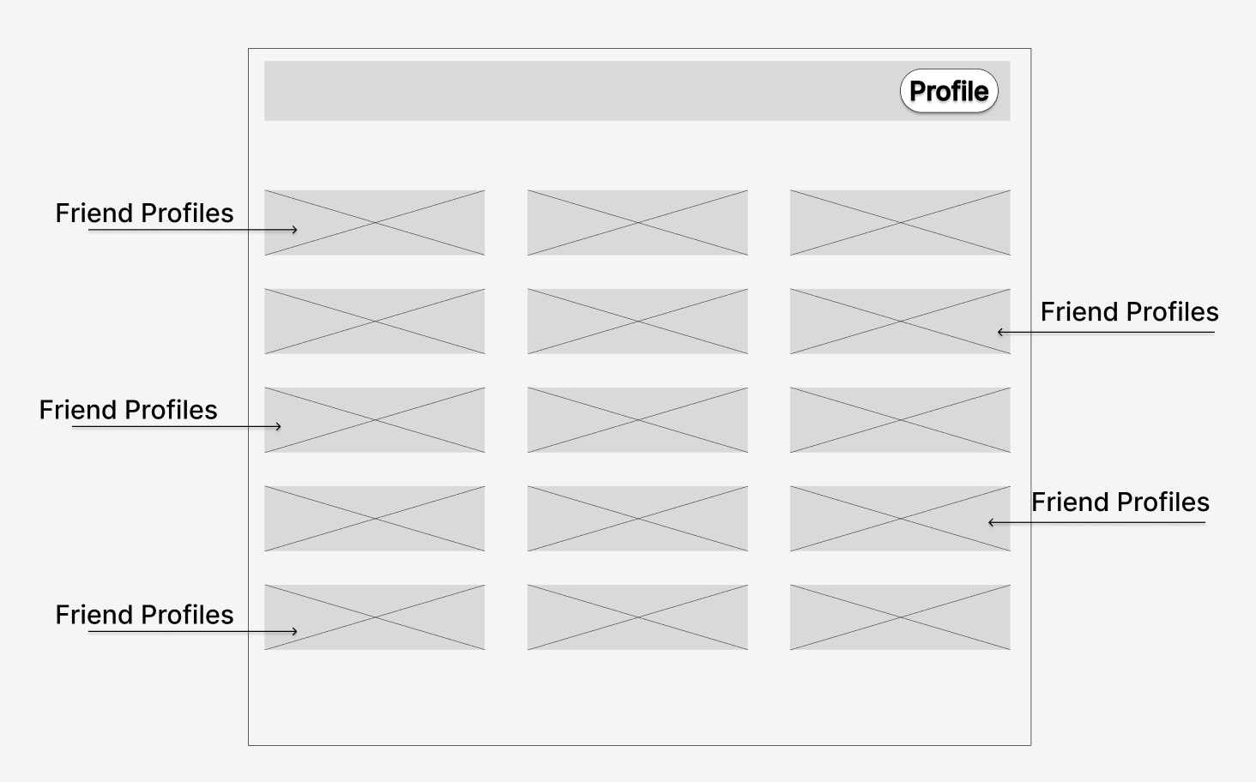

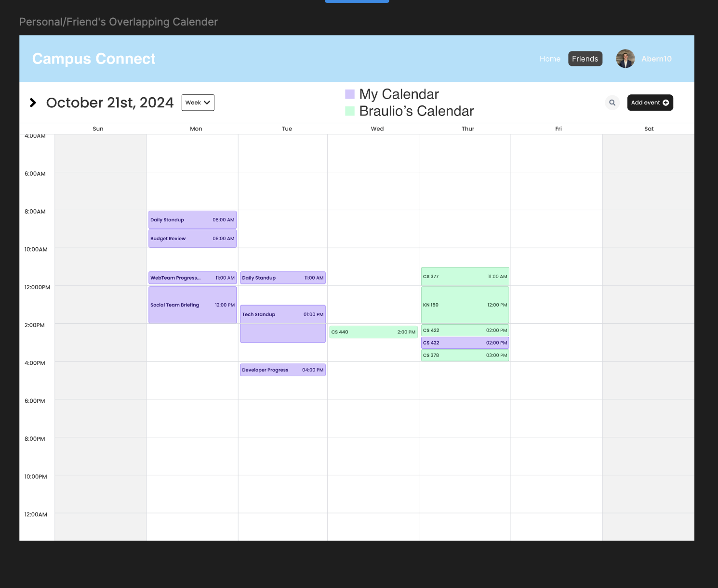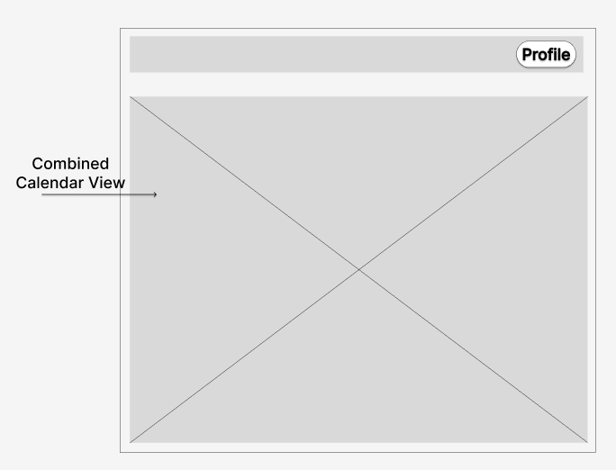

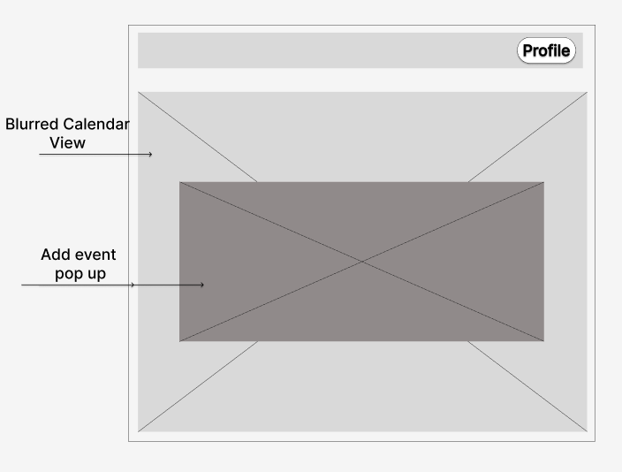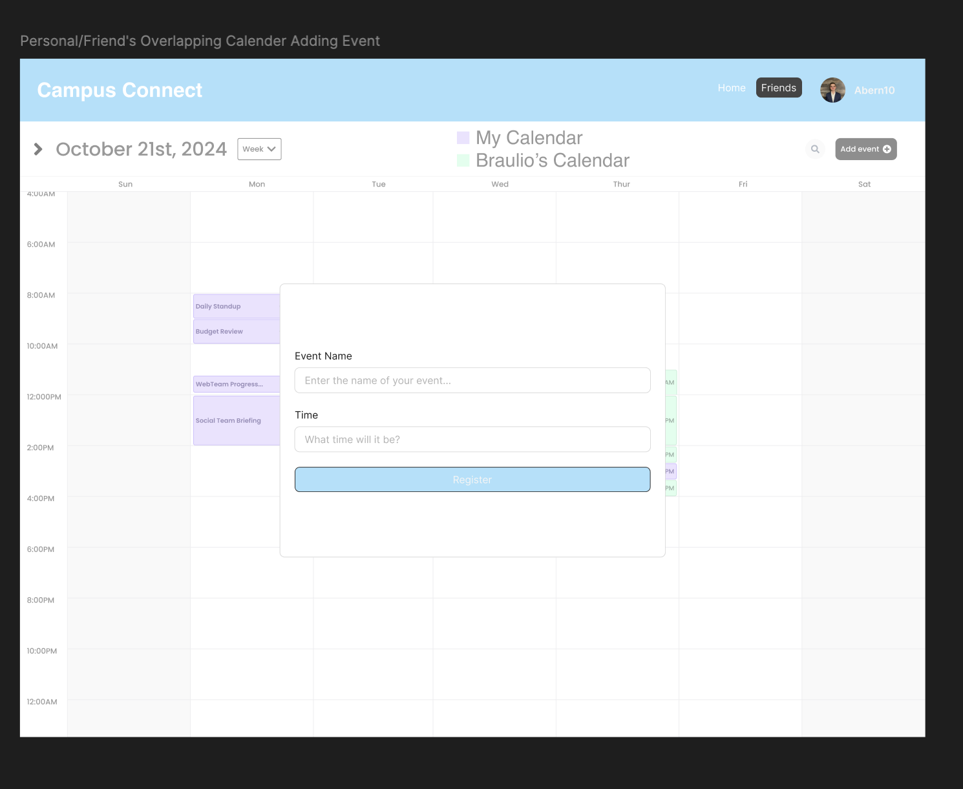

Storyboard: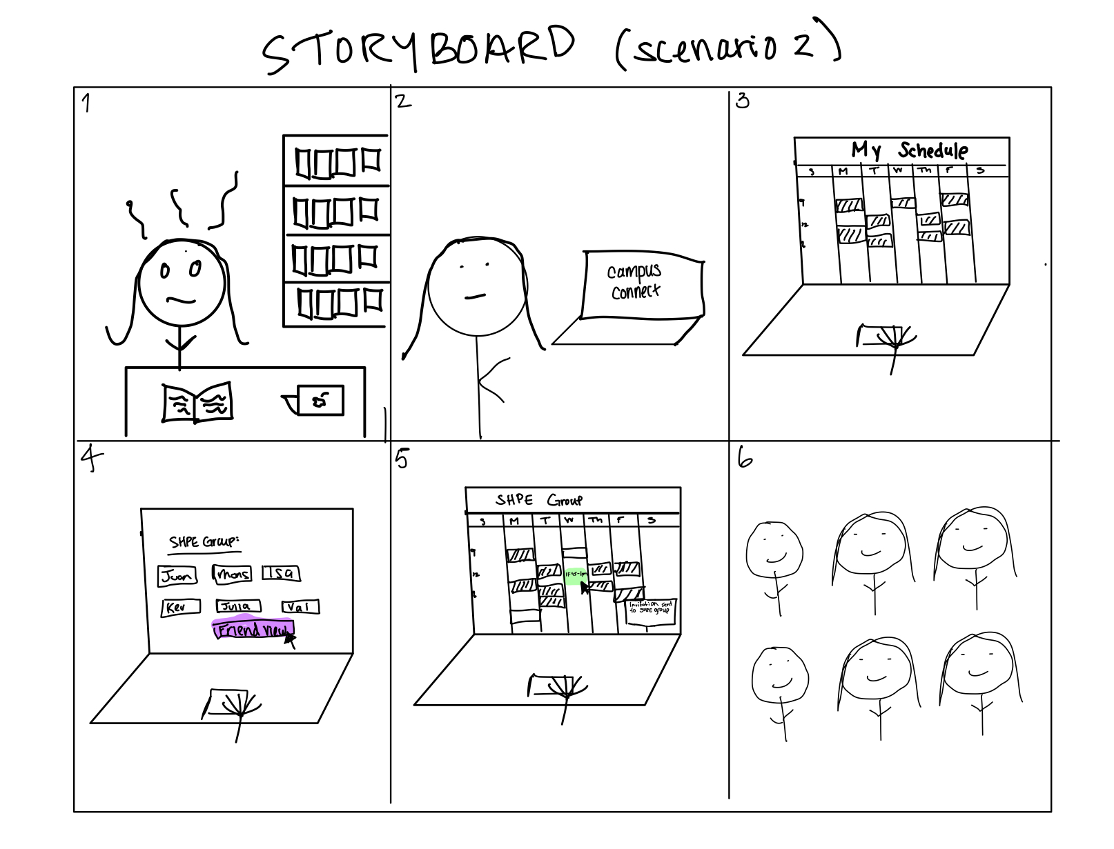

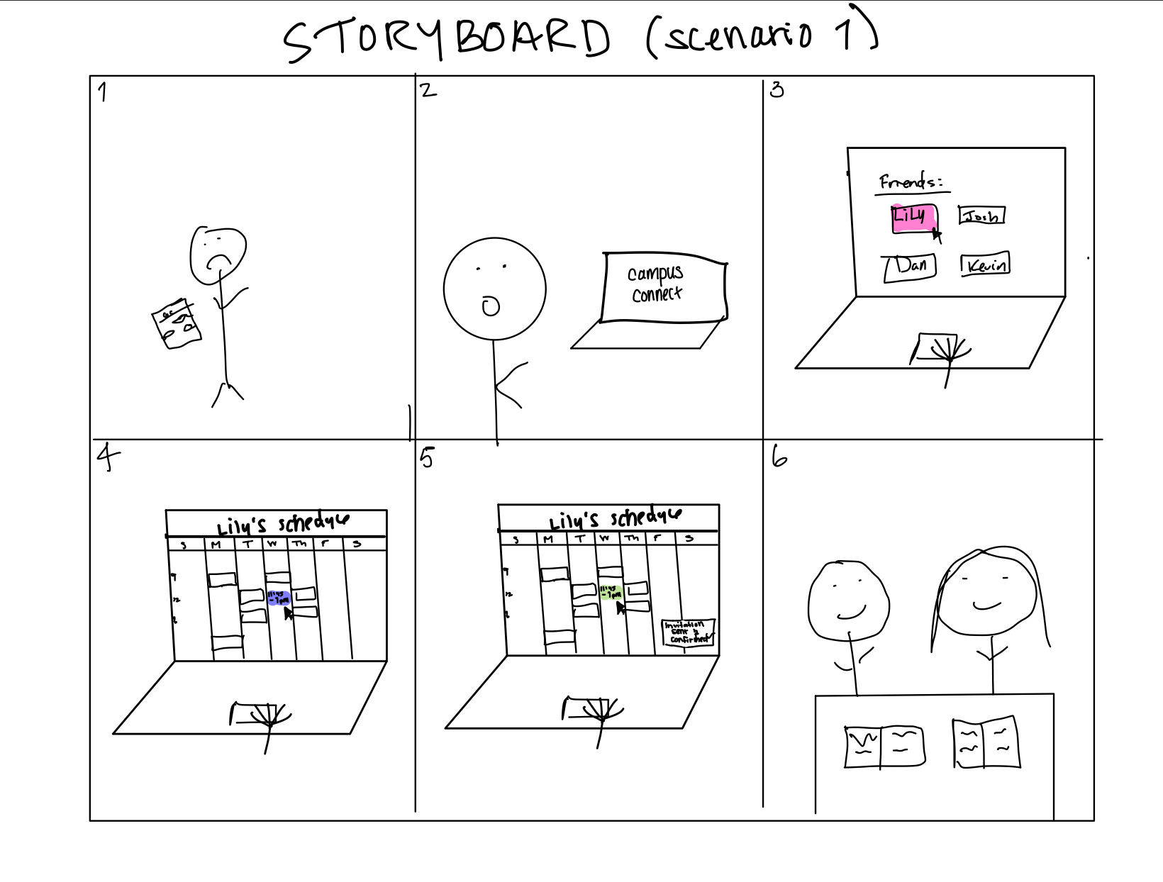

**Iterative design  
  
Initial Design:** Started with key features like real-time availability, personal schedule input, and visual schedule representation, using personas like Wendy (commuter student) and Marty (involved student) to reflect different user needs.

**Refining Based on Feedback:** After testing, updated requirements to include clearer notifications and schedule conflict resolutions. Personas were adjusted to better reflect users' needs, like giving Wendy more real-time notifications and offering Marty detailed views of schedule overlaps.

**Prototyping:** Created a low-fidelity prototype to test usability, focusing on how users navigate the app and receive feedback for key actions like confirming meetups or scheduling updates.

**Iterating:** Further refined the design based on test results, improving features such as notifications, conflict resolution, and interaction flow between "personal" and "friend" views.

**Final Refinement:** The prototype now offers clearer transitions, more intuitive notifications, and smoother interactions, aligning the design with user needs after multiple iterations. **Button Feedback:** Color and size changes when buttons are selected, helping users know when actions are recognized. Clarifying how the feedback persists (e.g., color remains) could improve clarity.

**Notifications:** Real-time availability and notifications after scheduling meetings give clear feedback that actions (e.g., confirming a study session) are successful. Specifying how notifications appear (e.g., popups or sound) would make this clearer.

**View Transitions:** Switching between personal and friend schedules is key. Ensuring users know they've successfully switched views with clear feedback or visual transitions would improve clarity.

**Enhancements:** Adding loading indicators, confirmation messages, and smoother transitions between actions (like calendar views) would help clarify feedback further.